**V1 DML**

**Question 1**

**Write an inner query that display name of all those customers whose order shipped date is in year 2006. (Use EXISTS operator)**

[*select*](http://localhost/phpmyadmin/url.php?url=https://dev.mysql.com/doc/refman/5.5/en/select.html)*C.first_name from Customers as C where Exists (*[*select*](http://localhost/phpmyadmin/url.php?url=https://dev.mysql.com/doc/refman/5.5/en/select.html)*O.customer_id from orders as O where C.id=O.customer_id*[*and*](http://localhost/phpmyadmin/url.php?url=https://dev.mysql.com/doc/refman/5.5/en/logical-operators.html#operator_and)*O.shipped_date*[*like*](http://localhost/phpmyadmin/url.php?url=https://dev.mysql.com/doc/refman/5.5/en/string-comparison-functions.html#operator_like)*("2006-%"))*

**Question 2**

**Write an co relate query that display name of every product with min, max, average and total quantity ordered in all orders.**

[*select*](http://localhost/phpmyadmin/url.php?url=https://dev.mysql.com/doc/refman/5.5/en/select.html)*product_Name, (*[*select*](http://localhost/phpmyadmin/url.php?url=https://dev.mysql.com/doc/refman/5.5/en/select.html)[*max*](http://localhost/phpmyadmin/url.php?url=https://dev.mysql.com/doc/refman/5.5/en/group-by-functions.html#function_max)*(quantity) from order_details where products.id = order_details.product_id), (*[*select*](http://localhost/phpmyadmin/url.php?url=https://dev.mysql.com/doc/refman/5.5/en/select.html)[*min*](http://localhost/phpmyadmin/url.php?url=https://dev.mysql.com/doc/refman/5.5/en/group-by-functions.html#function_min)*(quantity) from order_details where products.id = order_details.product_id), (*[*select*](http://localhost/phpmyadmin/url.php?url=https://dev.mysql.com/doc/refman/5.5/en/select.html)[*avg*](http://localhost/phpmyadmin/url.php?url=https://dev.mysql.com/doc/refman/5.5/en/group-by-functions.html#function_avg)*(quantity) from order_details where products.id = order_details.product_id), (*[*select*](http://localhost/phpmyadmin/url.php?url=https://dev.mysql.com/doc/refman/5.5/en/select.html)[*sum*](http://localhost/phpmyadmin/url.php?url=https://dev.mysql.com/doc/refman/5.5/en/group-by-functions.html#function_sum)*(quantity) from order_details where products.id = order_details.product_id) From products*

**Write a co-related query that display name of those customers whose at least one order has status id equals to zero. (Use EXISTS operator)**

*select C.first_name,C.last_name from customers as C where Exists ( select O.customer_id from orders as O where C.id=O.customer_id and O.status_id=0)*

**Question 4**

Display Name of all products with total amount of all its purchased till now.

**[Use Joins. No cross product / Co-related sub query / nested subquery is allowed.] Hint: You will use products and purchase_order_details table to solve this query.**

*SELECT p.product_name, (pur.quantity * pur.unit_cost)*

*FROM products p INNER JOIN purchase_order_details pur*

*ON p.id = pur.product_id GROUP BY p.id;*

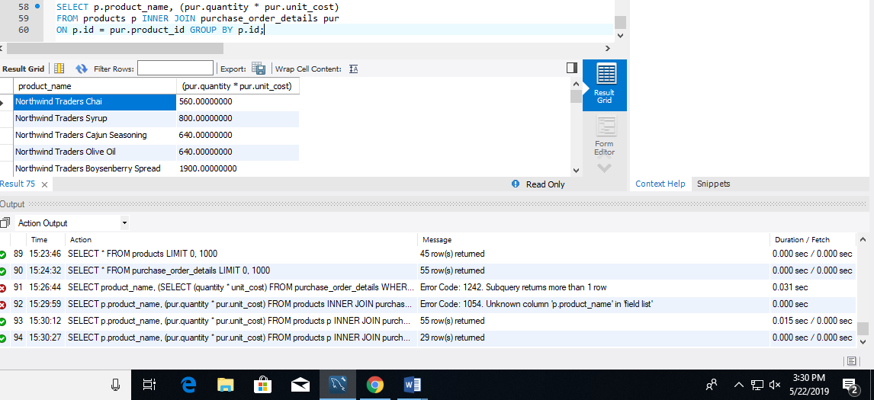

**Question 5**

Display name of all products categories with minimum, maximum, average and sum of list_price of product belongs to it. **[You need to make one query that display all above values, not separate/individual query]**

*SELECT category, MIN(list_price), MAX(list_price), AVG(list_price), SUM(list_price) FROM products GROUP BY category;*

